**Term Project (1): Statistics of Gas Prices**

CIST2742 – Spring 2021

**Specifications:**

The data for this product is stored in the text file named GasPrice.txt. The file contains the weekly average prices for a gallon of gas in the United States, beginning on April 5th, 1993, and ending on August 26th, 3013. The following is a sample of the first few lines of the data file.

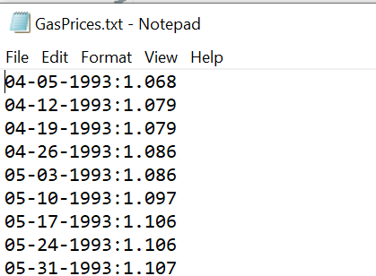

Each line in the file contains the average price for a gallon of gas on a specific date. Each line is formatted in this way:

*MM-DD-YYYY:Price*

Where MM is the two-digit moth, DD is two-digit day, and YYYY is the four-digit year. Price is the average price per gallon of gas on the specific day.

For this project, you are to develop one or more programs that read the data from the data file, and perform these tasks:

**Average Price Per Year**: Calculate the average price of gas per year, for each year in the file.

**Average Price Per Month**: Calculate the average price for each month in the file.

**Highest and Lowest Prices Per Year**: For each year in the data file, determine the date and amount for the lowest price, and the highest price.

**List of Prices, Lowest to Highest**: Generate a text file that lists the dates and prices. Sorted from lowest price to the highest.

**List of Prices, Highest to Lowest**: Generate a test file that lists the dates and prices. Sorted from highest price to the lowest.

You may write one program to do all these tasks, or write multiple programs, one for each task.

**Requirements:**

This is an individual project, each student is required to complete it independently

The system developed should work as specified

The program should be well-structured and modularized for code-reuse and easy maintenance

The program should be well-documents using docstring

The program should follow the conventions specified in PEP 8 -- [PEP 8 -- Style Guide for Python Code | Python.org](https://www.python.org/dev/peps/pep-0008/).

In addition to a working program, screenshots of test runs should be also submitted.